SCHOOL CRM / ERP SYSTEM
Complete Database Schema Design & Process Flowchart Document
(Flutter + Supabase Backend — 12 Modules, 104 Database Tables)

Prepared as a complete technical schema and process-flow reference
August 2026

Table of Contents
1. Introduction and Tech Stack
2. System Architecture — Overall Flow
3. Authentication / Login Flow
4. Complete Database Schema — Module-wise (104 Tables)
4.1 Core / Academic Setup
4.2 Students Module
4.3 Teachers Module
4.4 Teacher Portal Module
4.5 Attendance Module
4.6 Fees & Accounts Module
4.7 Examination Module
4.8 Transport Module
4.9 Hostel Module
4.10 HR & Payroll Module
4.11 Inventory Module
4.12 Parents & Communication Module
5. Module-wise Process Flowcharts (all 12 modules)
6. Entity-Relationship (ER) Diagrams — Domain-wise
7. Conclusion and Notes

1. Introduction
This document was generated by scanning the entire backend codebase of your School CRM / ERP project (Flutter + Supabase). It documents all 104 Supabase tables used across the project, their columns, and how data flows through every module — presented with proper flowcharts, not just theory. No module or table has been left out.

Tech Stack
- Frontend: Flutter (Web, Android, iOS, Windows, Linux — multi-platform)
- Backend: Supabase (PostgreSQL + Auth + Row Level Security)
- Authentication: Supabase Auth — signInWithPassword() followed by a role lookup in the profiles table
- State Management: Provider / ChangeNotifier pattern (app_state.dart, app_store.dart, app_providers.dart)

Modules Overview (12 modules in total)
- Core / Academic Setup — 11 tables
- Students — 3 tables
- Teachers — 1 tables
- Teacher Portal — 18 tables
- Attendance — 1 tables
- Fees & Accounts — 8 tables
- Examination — 21 tables
- Transport — 8 tables
- Hostel — 11 tables
- HR & Payroll — 16 tables
- Inventory — 2 tables
- Parents & Communication — 4 tables
In total, the system uses 104 Supabase tables, all documented module-wise in Section 4 below.

2. System Architecture — Overall Flow
The flowchart below shows the high-level architecture of the entire system — from user login, through role-based dashboard routing, through every module, down to the Supabase PostgreSQL database.
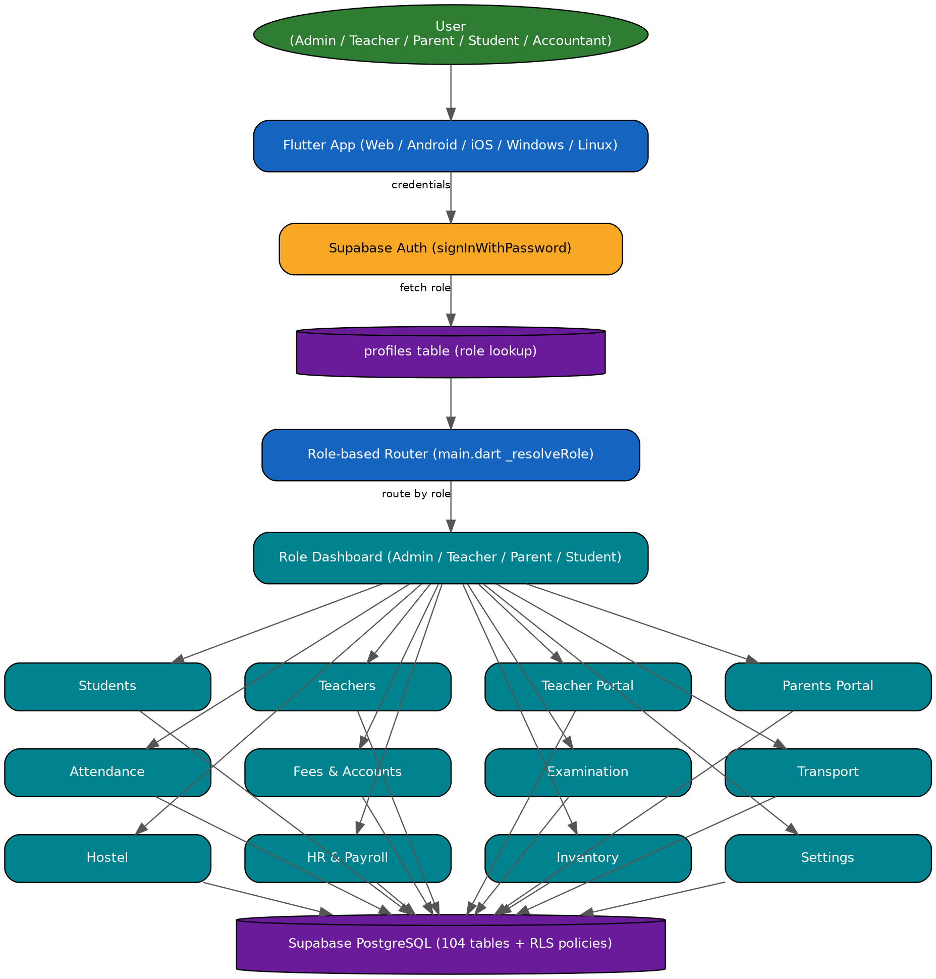

3. Authentication / Login Flow
The login process — from Supabase Auth through to fetching the role from the profiles table and routing to the correct dashboard — is shown step-by-step below.
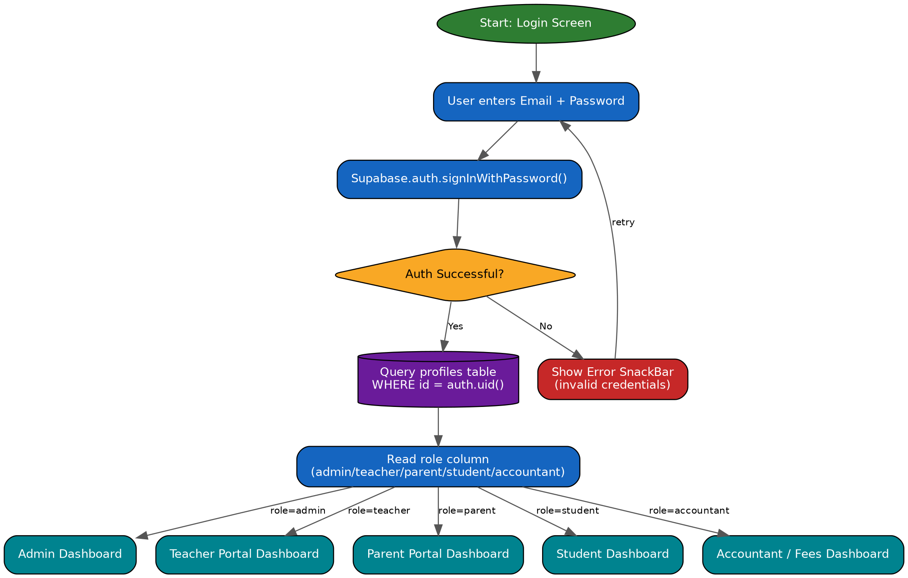

4. Complete Database Schema — Module-wise (104 Tables)
This section lists every table for each module, its purpose, and its actual columns (extracted from the codebase — from insert/update/select calls). PK = Primary Key, FK = Foreign Key. Almost every table has a default `id` primary key, and most tables also carry an `institution_id` column for multi-tenant isolation.

4.1 Core / Academic Setup
This module has 11 table(s):
Table Name | Purpose | Key Columns
profiles | Identity + role record for every logged-in user (admin/teacher/parent/student/accountant), linked to Supabase Auth's uid. | institution_id, role
school_settings | School-level global settings such as institution name, academic year configuration, and branding. | academic_year, is_dark_mode, org_name, toggles, updated_at
academic_sessions | Academic session/year master (e.g. 2025-26) with a flag for the currently active session. | created_at, id, institution_id, is_current, name
sections | Class + section master (e.g. Class 8 - A). | id, name
subjects | Subject master, linked to a course. | id, name
courses | Class/Course master to which subjects and exams are linked. | id, name
timetable_slots | Section-wise timetable slots (day_of_week, start/end time) shown in the Parent Portal. | day_of_week, end_time, id, section_id, start_time, subject_id, teacher_id
notifications | Generic system-wide notifications/alerts feed. | body, channel, delivery_status, id, institution_id, read, sent_at, target_role, title
school_events | School calendar events (functions, holidays, PTM dates, etc.) shown to parents. | end_time, event_date, id, start_time, title
payments | Generic cross-module payments feed used by the dashboard's Recent Activities widget. | amount, confirmed_at, created_at, status, student_fee_id
employees | Legacy/summary employee-designation lookup used by the dashboard repository. | designation

4.2 Students
This module has 3 table(s):
Table Name | Purpose | Key Columns
students | Master student record — name, class, section, roll no., institution_id. All other modules (Fees, Attendance, Exam, Hostel, Transport, Parents) link back to this table. | admission_id, class_num, contact_phone, course_id, created_at, current_semester, date_of_birth, enrollment_no, full_name, guardian_name, id, institution_id, section, section_id, status
tc_requests | Transfer Certificate request raised by a student/parent, with its approval status. | approved_on, id, reason, requested_on, status, student_id
admissions | New student admission intake record (from application through to entry into the students table). | applicant_name, contact_email, contact_phone, course_id, date_of_birth, institution_id

4.3 Teachers
This module has 1 table(s):
Table Name | Purpose | Key Columns
teachers | Master teacher/staff record, linked to Teacher Portal login (role='teacher') and managed from the admin's Teachers module. | created_at, department, email, emp_id, id, institution_id, name, phone, status, subject

4.4 Teacher Portal
This module has 18 table(s):
Table Name | Purpose | Key Columns
notices | General notices/circulars posted by a teacher or admin. | audience, body, pinned, title
homework | Homework assigned by a teacher (class, subject, due date). | class_name, due_date, subject, title
homework_submissions | Record of homework submitted by students, linked to the homework table. | homework, status, updated_at
assignments | Master list of class assignments/projects. | class_name, due_date, graded, pending_count, teacher_id, title, total_count
attendance | Teacher Portal's class-wise daily attendance table (separate from attendance_records). | class_name, date, marked_by, status, student_id, updated_at
class_timetable | Teacher Portal's weekly class timetable (day, period, class, subject, room). | class_name, created_at, day, id, institution_id, period_order, room, subject, time
documents | Documents uploaded by teachers/staff (certificates, ID proofs, etc.). | file_name, file_url, status, student_id, type
assessment_records | Internal assessment/test marks record for a student (Gradebook). | category, date, max_marks, obtained, student_id, title
payslips | Monthly payslip records for teachers/staff (basic, HRA, deductions, net pay). | allowances, basic, created_at, hra, id, month, net_pay, other_deductions, provident_fund, staff_name, tax, year
staff_leave_requests | Teacher/staff leave application and its approval status. | approver_note, days, from_date, leave_type, reason, staff_id, staff_name, status, to_date
staff_messages | Teacher-to-teacher or staff-to-admin internal messaging. | body, recipient, sender_id, unread
tp_exams | Class-level short tests/exams scheduled from within the Teacher Portal. | class_name, date, subject, title
tp_lesson_plans | Teacher lesson plans, linked to syllabus chapters. | class_name, date, title
tp_notifications | Teacher-specific notification feed. | read
tp_ptm_slots | Available time slots for Parent-Teacher Meetings. | date, parent_name, student_name, time
tp_resources | Teaching resources/files shared by a teacher. | category, subtitle, title
tp_syllabus_chapters | Subject-wise syllabus chapter master, linked to lesson plans. | class_name, completed_topics, subject, title, total_topics
tp_todos | A teacher's personal to-do list. | done, title

4.5 Attendance
This module has 1 table(s):
Table Name | Purpose | Key Columns
attendance_records | The system's central attendance table — the Attendance module, Students dashboard, and Parent Portal all compute attendance percentage from this table. | marked_by, section_id, session_date, status, student_id, students

4.6 Fees & Accounts
This module has 8 table(s):
Table Name | Purpose | Key Columns
fee_structures | Class-wise fee-head master with amounts (e.g. Class 5 - Tuition Fee - Rs. 5000). | amount, class_num, created_at, fee_type, id, institution_id
fee_transactions | Transaction-level ledger entry for each fee payment. | cancelled, collected_by, date, discount, head_amounts, late_fee, mode, receipt_no, student_id, student_name, total_amount, utr
fee_payments | Receipt-level fee payment record, also shown in the Parent Portal. | amount_paid, payment_date, payment_mode, received_by, status, student_id
fee_waivers | Record of scholarships/discounts/waivers granted to students. | amount, id, institution_id, reason, requested_at, requested_by, requested_by_name, resolved_at, resolved_by, status, student_id
expenses | Record of the school's day-to-day/monthly expenses (Accounts module). | amount, approved_by, category, description, vendor
income_entries | Record of income sources other than fees. | amount, category, description, recorded_by, source
installments | Installment-wise breakup and due dates for a student's fees. | paid_amount, status
student_fees | Assigns a fee structure to each student — tracks installments and the amount due. | amount_due, amount_paid, discount_amount, due_date, id, status, student_id

4.7 Examination
This module has 21 table(s):
Table Name | Purpose | Key Columns
exam_answer_books | Record of the answer book/copy issued to each student. | anon_id, exam_id, examiner_id, id, identity_revealed, institution_id, status, student_id, subject_id
exam_audit_log | Audit trail of every critical action in the Examination module (security/compliance). | action, actor_role, actor_user_id, created_at, id, institution_id, module, new_value, previous_value, reference_id, session_info
exam_book_custody_events | Chain-of-custody log for answer books — issue, collection, transfer events (for security/audit). | actor_user_id, book_id, note, to_status
exam_certificates | Record of certificates issued after a result is declared. | institution_id, issued_by, result_id, student_id, verification_id
exam_eligibility | Record of which students are eligible for which exam. | exam_id, id, institution_id, reason, status, student_id
exam_evaluations | Marks given by a teacher after evaluating an answer book. | awarded, book_id, comment, examiner_id, id, institution_id, marks, maxMarks, questionNo, stage
exam_invigilator_duties | Schedule of which invigilator is assigned to which exam/room. | exam_id, id, institution_id, invigilator_id, room_id, subject_id, substitute_invigilator_id, substitute_needed
exam_invigilators | List of teachers eligible for invigilation duty. | id, institution_id, name, user_id
exam_malpractice_incidents | Log of malpractice/cheating incidents that occurred during an exam. | action_taken, description, exam_id, id, incident_type, institution_id, reported_by, room_id, seat_code, status, student_id
exam_marks_corrections | Request/log for correcting an error in marks entry. | approved_by, book_id, id, institution_id, new_value, original_value, reason, requested_by, status
exam_notifications | Exam-related notifications (date sheet, result declared, etc.). | audience, body, created_at, id, institution_id, scheduled_for, status, title
exam_result_subjects | Subject-wise marks breakup for a result. | grade, id, marks_obtained, max_marks, result_id, subject_id
exam_results | Compiled final result per student per exam (percentage, grade, rank). | exam_id, id, overall_grade, pass, percentage, rank, stage, student_id
exam_revaluation_requests | Revaluation request raised by a student/parent. | book_id, id, institution_id, original_marks, reason, revised_marks, status, student_id, subject_id
exam_rooms | Rooms allocated for conducting an exam. | capacity, id, institution_id, name
exam_seat_assignments | Record of a student's assigned seat in an exam room. | exam_id, id, institution_id, room_id, seat_code, student_id
exam_subject_schedule | Subject-wise date, time, and max/passing marks for each exam. | end_time, exam_date, exam_id, start_time, subject_id
exams | Exam master (name, session, type — unit test/half-yearly/final). | course_id, exam_type, id, institution_id, name, ranking_enabled, session_id, status
question_bank_items | Subject/chapter-wise question bank with difficulty and marks. | chapter, course_id, difficulty, id, institution_id, marks, question_text, question_type, status, subject_id, tags, topic
question_papers | Question paper sets auto-generated from the question bank. | approved, created_at, exam_id, id, institution_id, question_ids, resolved_at, resolved_by, set_label, status, subject_id, submitted_by, total_marks
results | Simplified overall result summary per student, used by the Parent Portal. | created_at, exam_id, id, overall_grade, percentage, student_id, term

4.8 Transport
This module has 8 table(s):
Table Name | Purpose | Key Columns
routes | Bus/van route master (with stops). | id, institution_id, route_name, status
drivers | Driver master, linked to a vehicle. | full_name, id, institution_id, license_number, phone, route_name, status
vehicles | Master list of school vehicles (bus/van numbers). | driver_name, id, institution_id, route_id, seating_capacity, status, vehicle_number, vehicle_type
trips | Daily trip schedule for a route + vehicle. | driver_name, institution_id, route_name, status, trip_time, trip_type, vehicle_number
student_transport | Record of a student assigned to a specific route. | route_id
transport_attendance | Attendance for whether a student boarded a trip. | present, route_name, student_name
transport_fee_payments | Transport fee payment record. | amount, institution_id, payment_date, payment_mode, student_name
transport_messages | Route-wise transport alerts sent to parents. | created_at, id, preview, read, sender_name, sender_role

4.9 Hostel
This module has 11 table(s):
Table Name | Purpose | Key Columns
hostel_blocks | Hostel building/block master. | id, name
rooms | Rooms and their capacity within each block. | block_id, capacity, hostel_blocks, id, occupied, room_number, status
hostel_students | Record of a student admitted to a hostel room. | block_id, blood_group, guardian_phone, hostel_blocks, id, room_id, rooms, status, student_id, students
hostel_attendance | Daily attendance (roll call) for hostel students. | rooms, status, students
hostel_complaints | Complaints raised by a student (mess, maintenance, etc.). | status, students
hostel_fees | Hostel fee billing record. | hostel_students, status
hostel_leave_requests | Leave application to go home from the hostel. | status, students
hostel_maintenance_requests | Request for room/facility maintenance. | rooms, status
hostel_notices | Hostel-specific notices/circulars. | body, created_at, id, institution_id, posted_by, title
hostel_staff | Hostel warden/staff record, linked to a block. | block_id, created_at, id, institution_id, name, phone, role
hostel_visitors | Entry log for visitors to the hostel. | check_out, status, students

4.10 HR & Payroll
This module has 16 table(s):
Table Name | Purpose | Key Columns
hr_departments | Organization department master (Teaching, Admin, Accounts, etc.). | head, institution_id, name
hr_designations | Designation/post master within a department. | department, description, institution_id, name
hr_employees | HR module's master employee record (after onboarding post-recruitment). | created_at, department, designation, email, id, institution_id, name, phone, status
hr_attendance | Employee's daily attendance (check-in/check-out). | check_in, check_out, employee_id, hr_employees, institution_id, status
hr_leaves | Employee leave application and approval. | days, hr_employees, id, leave_type, reason, start_date, status
hr_shifts | Employee shift timing master. | created_at, end_time, id, institution_id, name, start_time
hr_salary_structures | Employee-wise salary structure (basic, HRA, allowances). | allowances, basic, created_at, employee_id, hra, id, institution_id
hr_payroll_records | Final compiled record of a monthly payroll run (unique per employee+month). | hr_employees
hr_allowance_deductions | Record of an employee's additional allowances/deductions. | enabled
hr_loans | Record of loans/advances given to an employee. | hr_employees
hr_tax_records | Employee's tax-related records (TDS, etc.). | hr_employees
hr_appraisals | Employee performance appraisal/rating record. | hr_employees
hr_jobs | Open job posting record (Recruitment). | created_at, department, id, institution_id, status, title
hr_candidates | Candidates who applied for a job. | application_status, created_at, id, institution_id, interview_status, job_id, name
hr_interviews | Candidate interview schedule and feedback. | candidate_id, created_at, feedback, id, institution_id, interview_date, interviewer
hr_offers | Status of the offer letter extended to a candidate. | status

4.11 Inventory
This module has 2 table(s):
Table Name | Purpose | Key Columns
inventory_items | Master list of school inventory items (stationery, lab equipment, etc.). | brand, category, code, institution_id, last_updated, location, name, quantity_on_hand, status, unit, unit_price
stock_movements | Stock-in / stock-out movement log for each item. | direction, in, institution_id, item_code, item_name, quantity

4.12 Parents & Communication
This module has 4 table(s):
Table Name | Purpose | Key Columns
parent_student_links | Links a parent account to their child(ren)'s student record. | parent_id, student_id
parent_teacher_threads | Parent-teacher chat thread master. | created_at, id, parent_id, subject, teacher_id
parent_teacher_messages | Individual chat messages within a thread. | body, sender_role, thread_id
library_books | Record of library books issued to a student (shown in the Parent Portal). | author, due_on, id, issued_on, returned, student_id, title

5. Module-wise Process Flowcharts
The following pages give a detailed process flowchart for every module — how data is created and updated in that module, which tables are involved, and the order in which the flow runs. Each flowchart is sized to use the full page for maximum readability.

5.1 Students Module — Flow
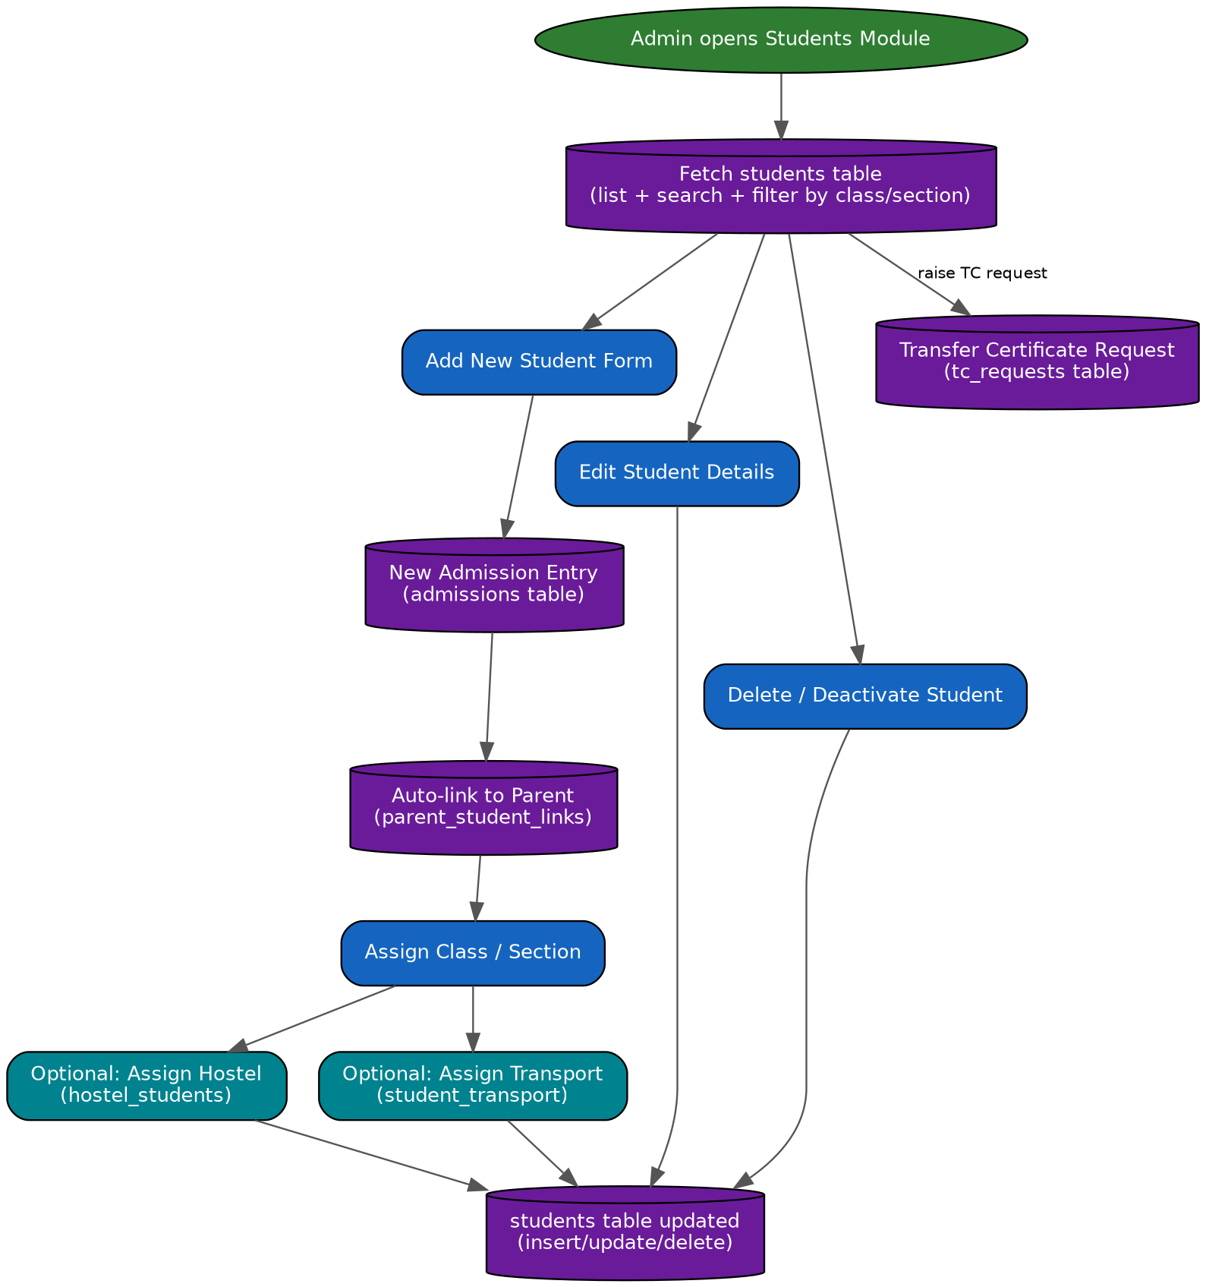

5.2 Teachers Module — Flow
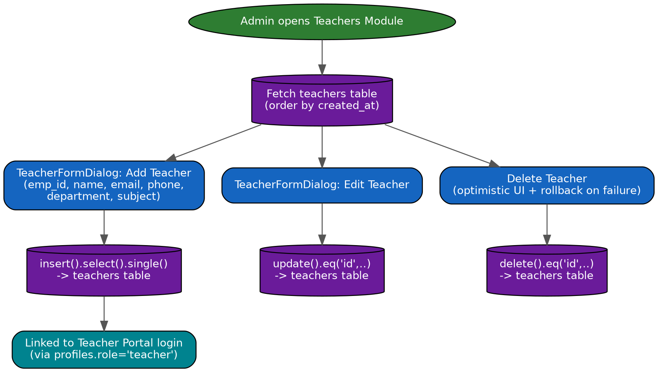

5.3 Teacher Portal Module — Flow
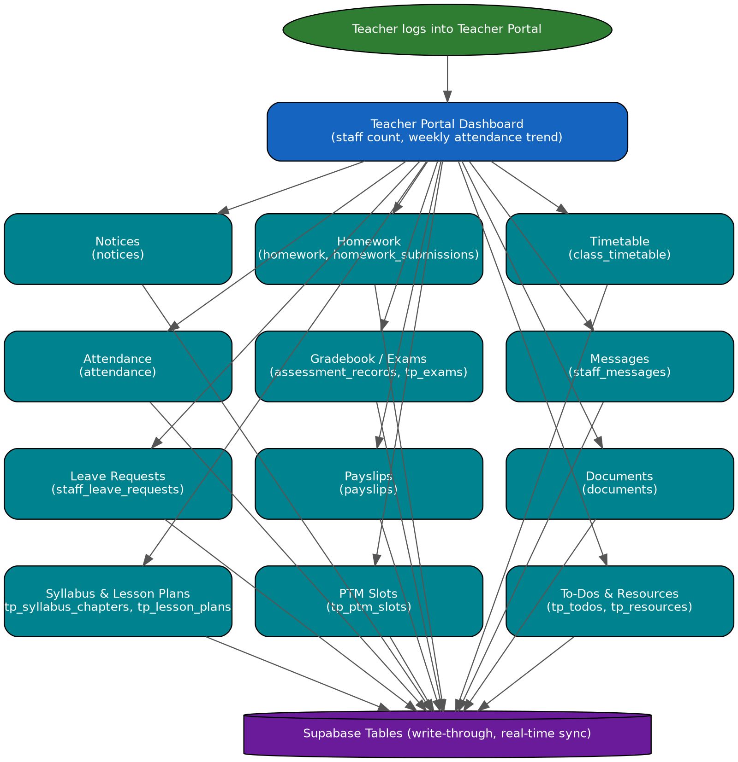

5.4 Attendance Module — Flow
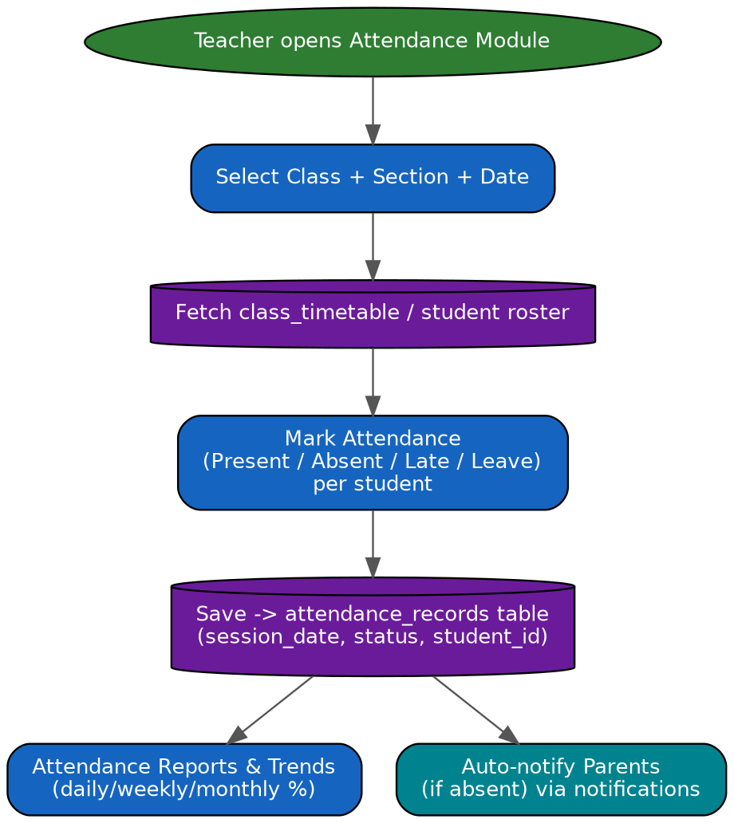

5.5 Fees & Accounts Module — Flow
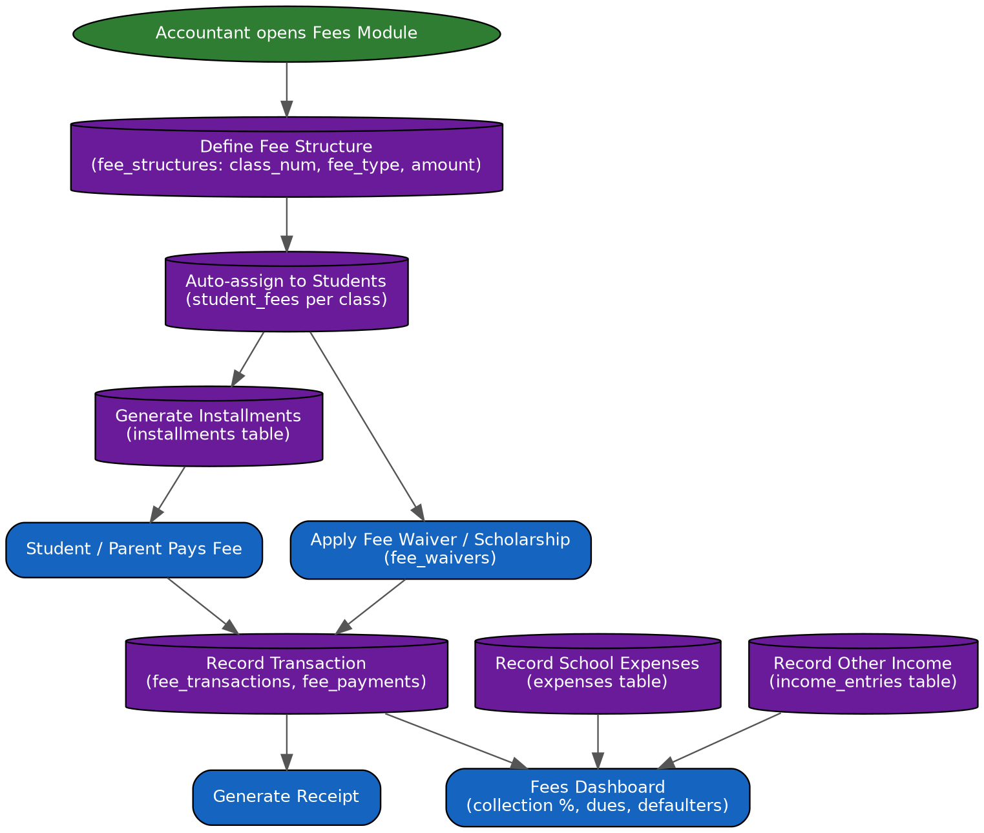

5.6 Examination Module — Flow (most detailed — 20+ tables)
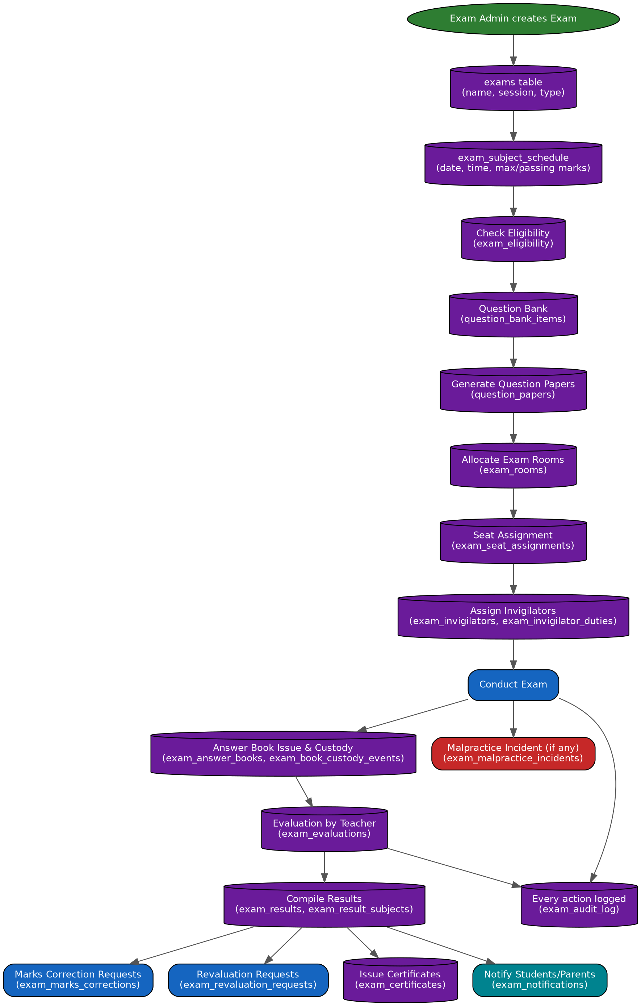

5.7 Transport Module — Flow
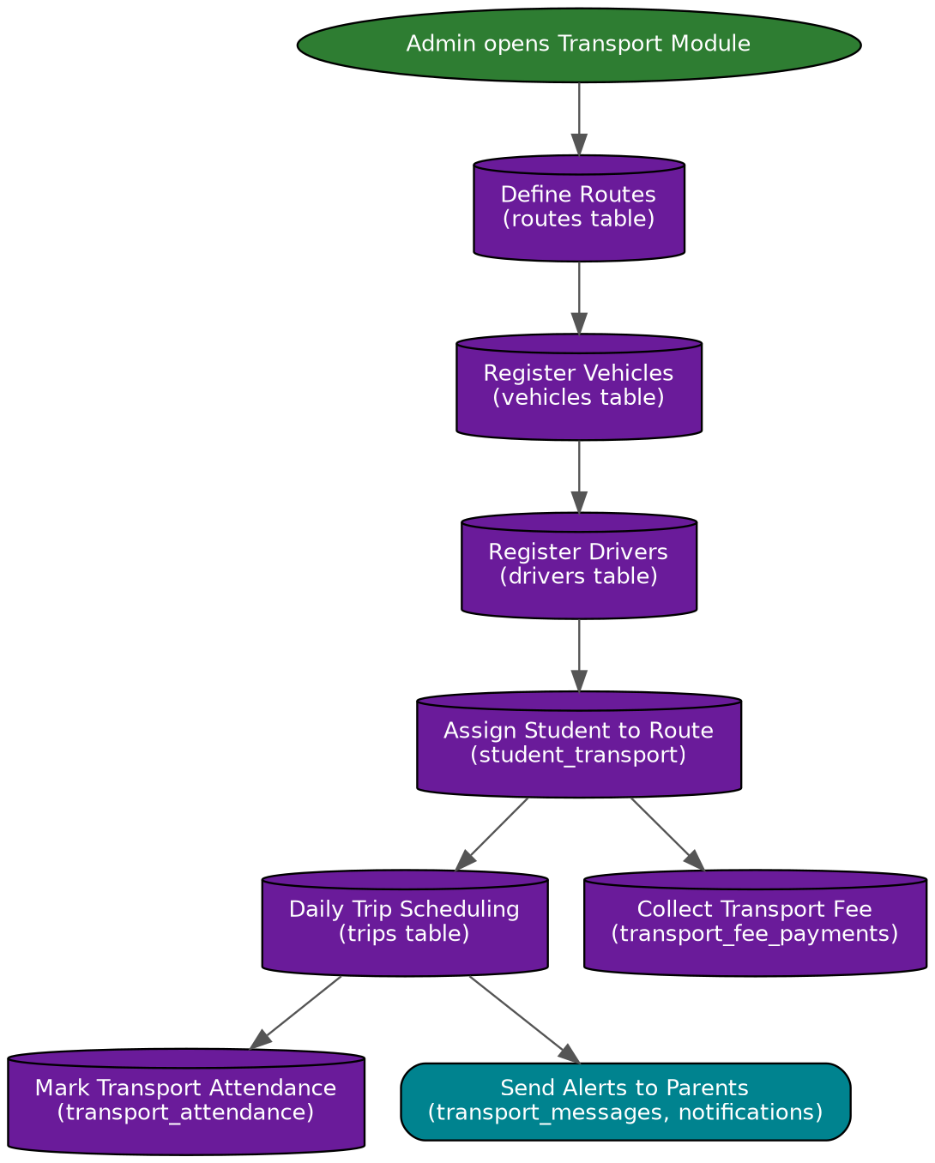

5.8 Hostel Module — Flow
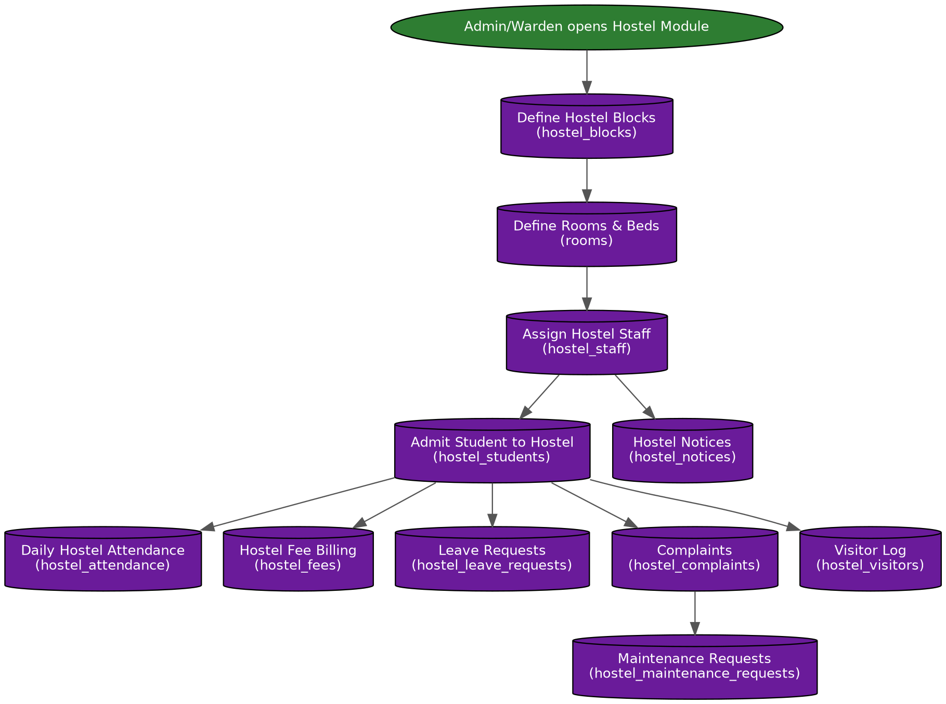

5.9 HR & Payroll Module — Flow
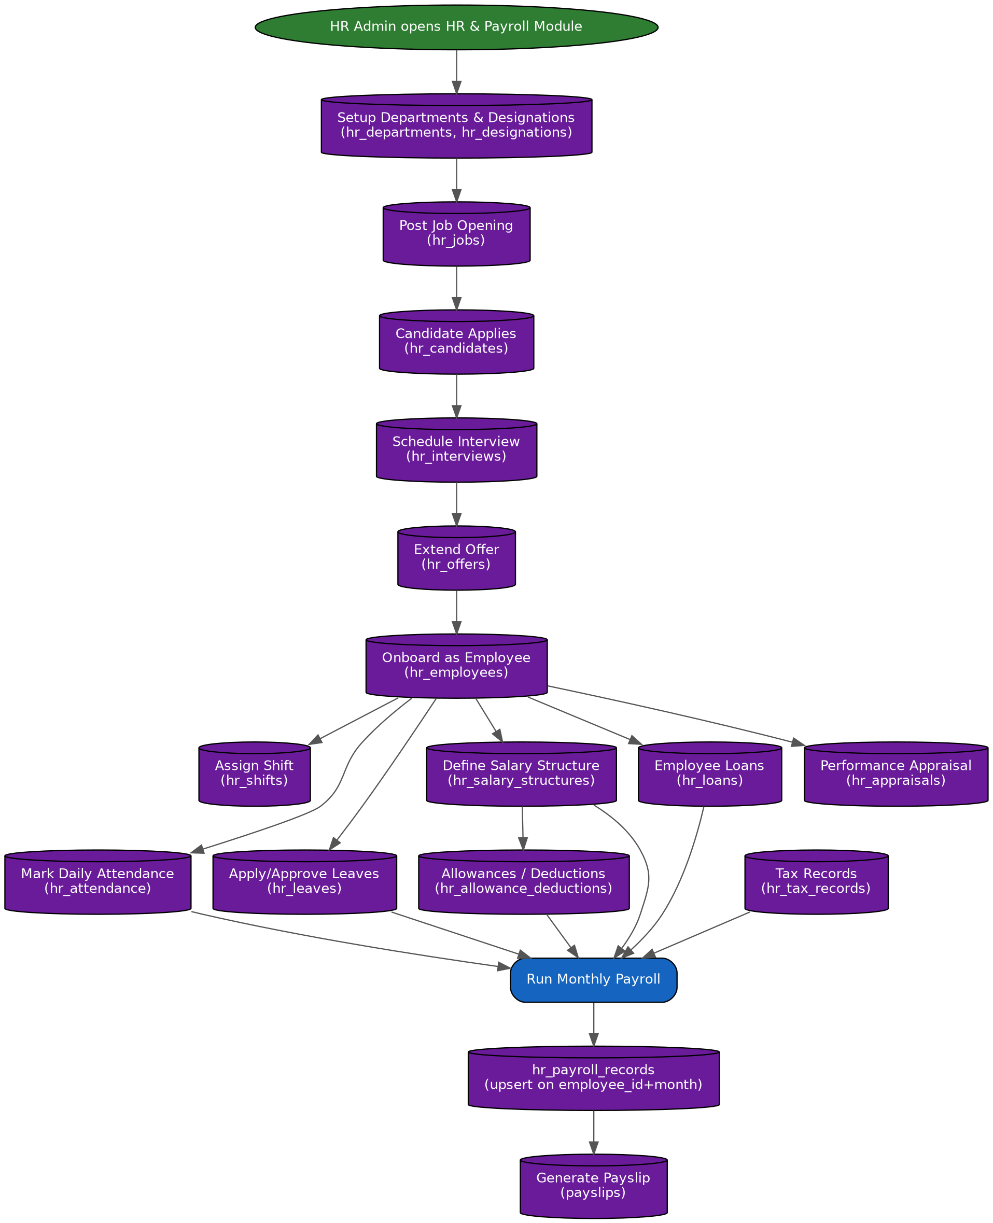

5.10 Inventory Module — Flow
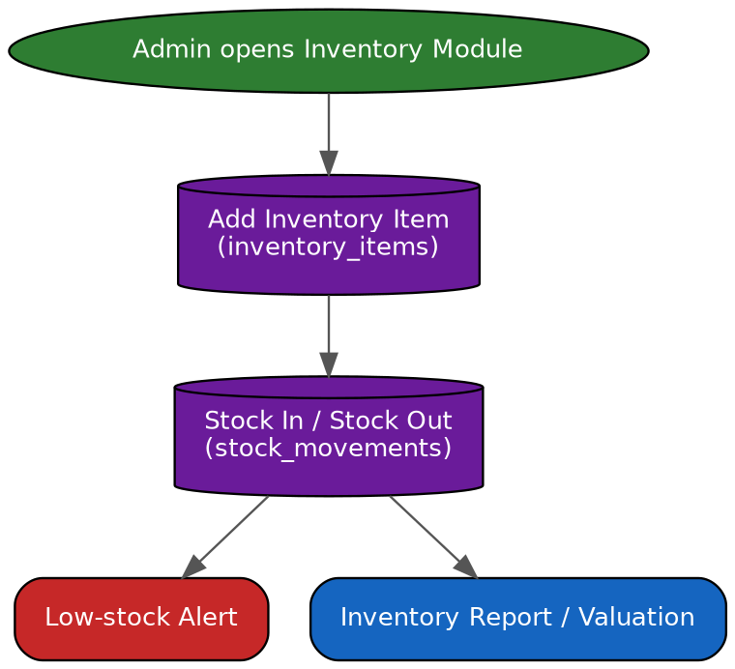

5.11 Parents Portal Module — Flow
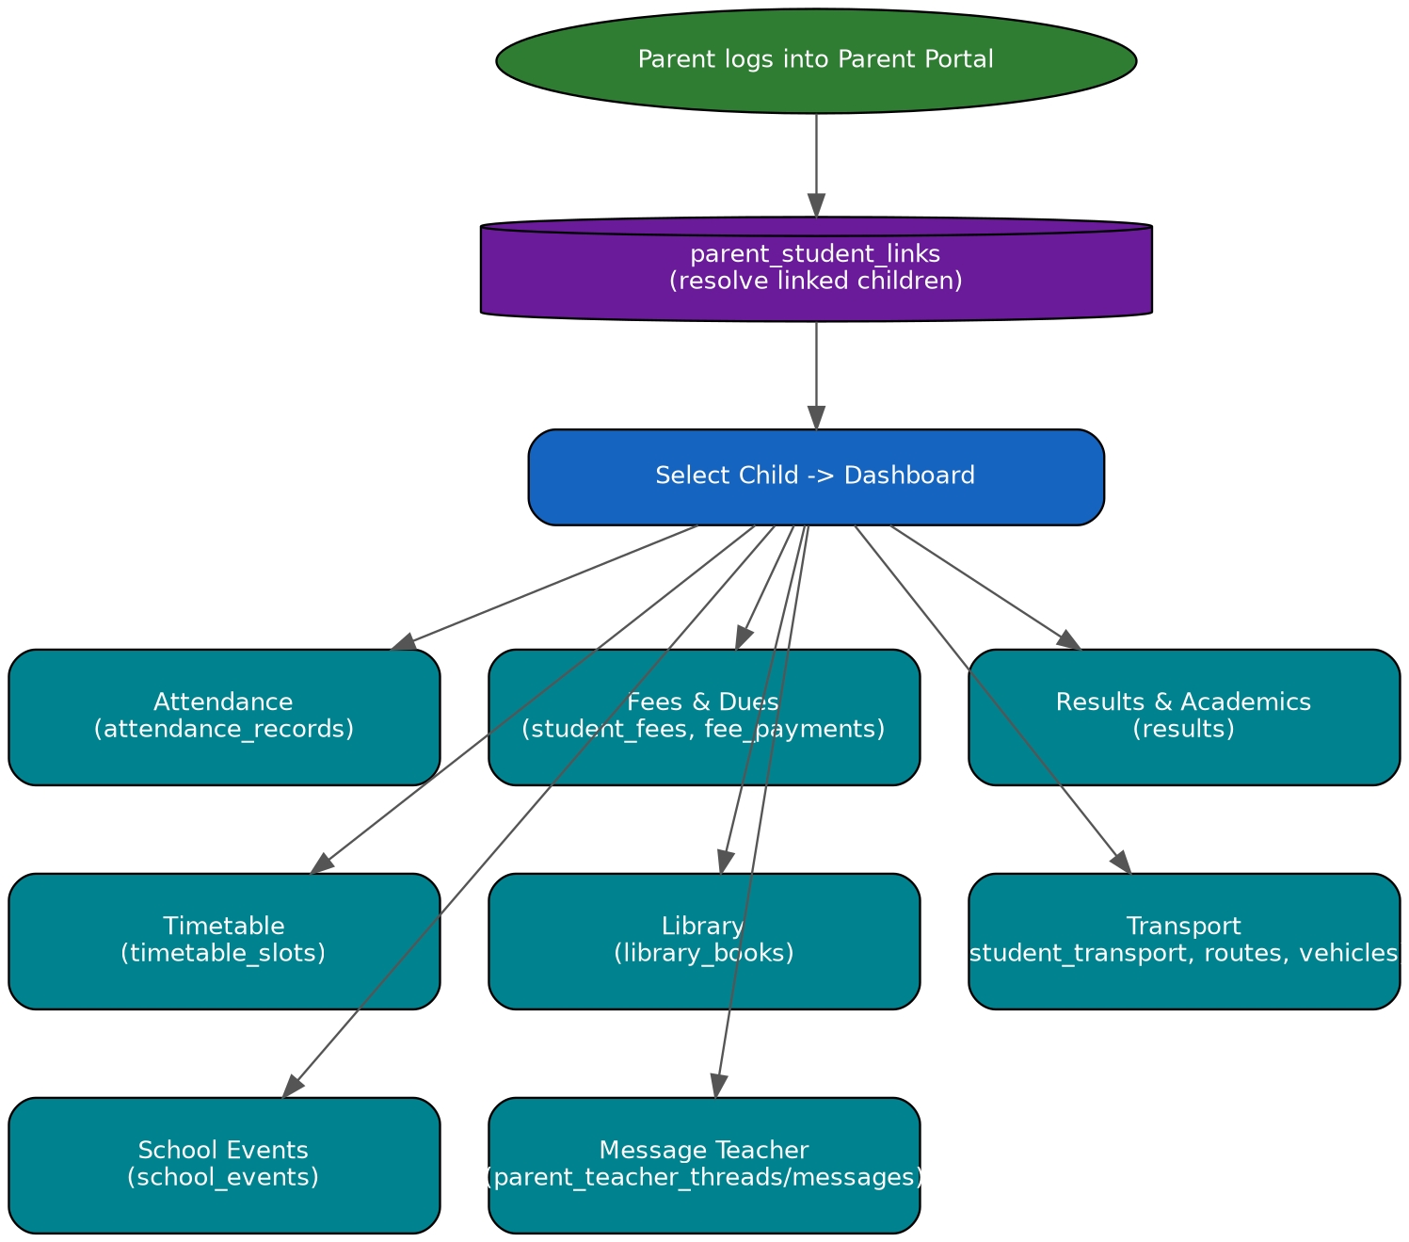

6. Entity-Relationship (ER) Diagrams — Domain-wise
Showing all 104 tables in a single diagram would not be readable, so the ER diagrams are grouped into 7 logical domains. Each diagram shows Primary Key (PK) and Foreign Key (FK) relationships with arrows, and each is sized to fill its page.

6.1 Core / Academic Setup — ER Diagram
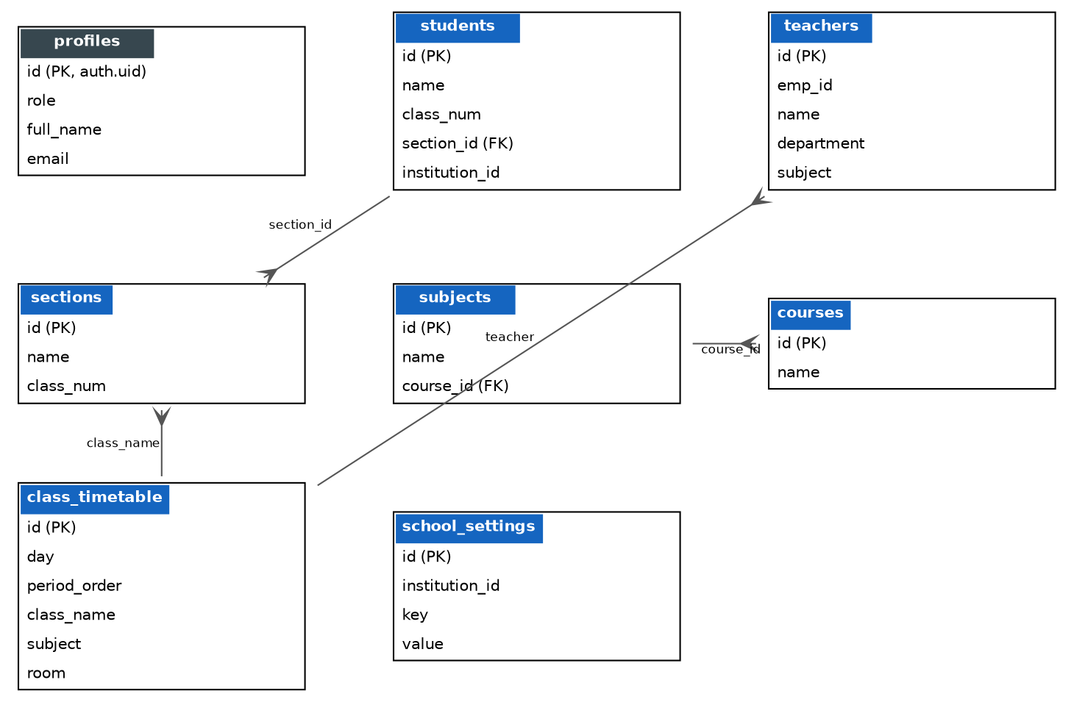

6.2 Fees & Accounts — ER Diagram
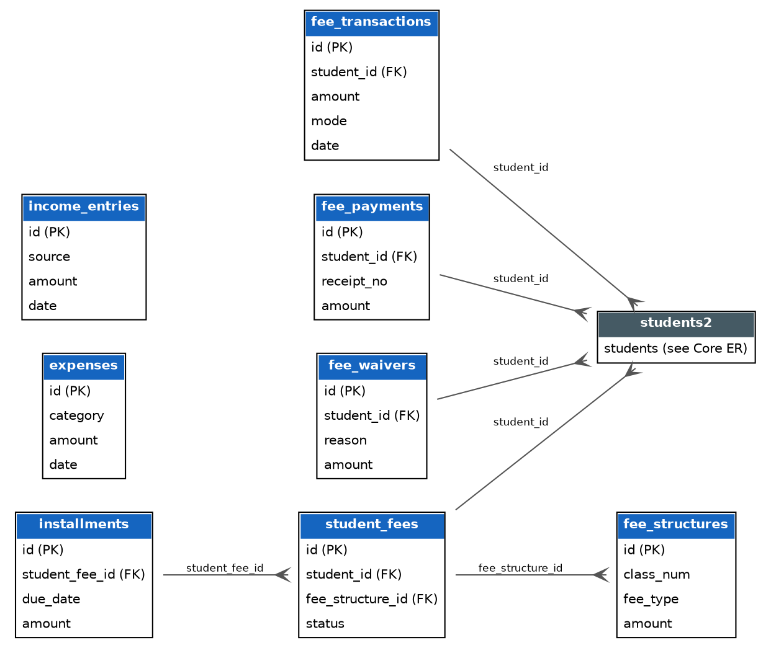

6.3 Examination — ER Diagram (Full 20 Tables)
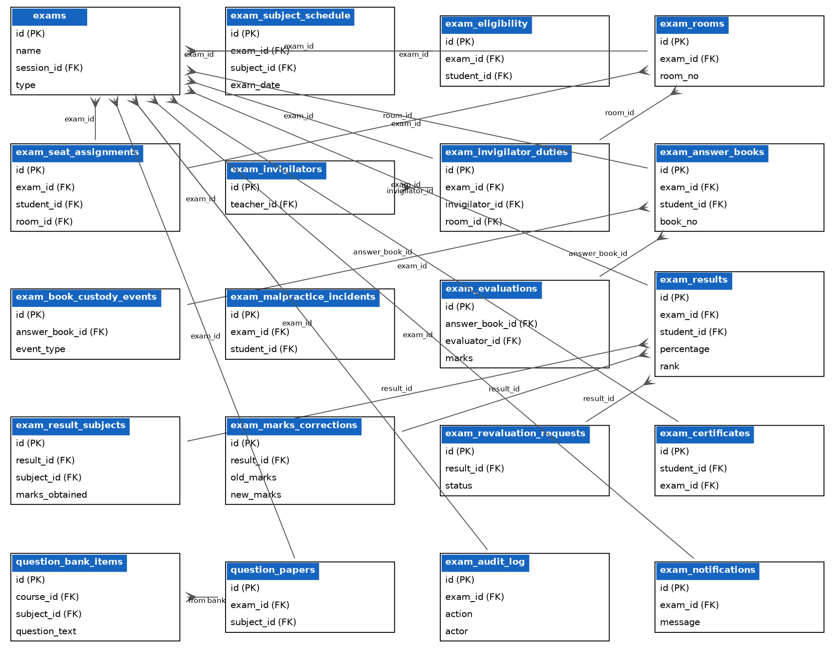

6.4 Hostel — ER Diagram
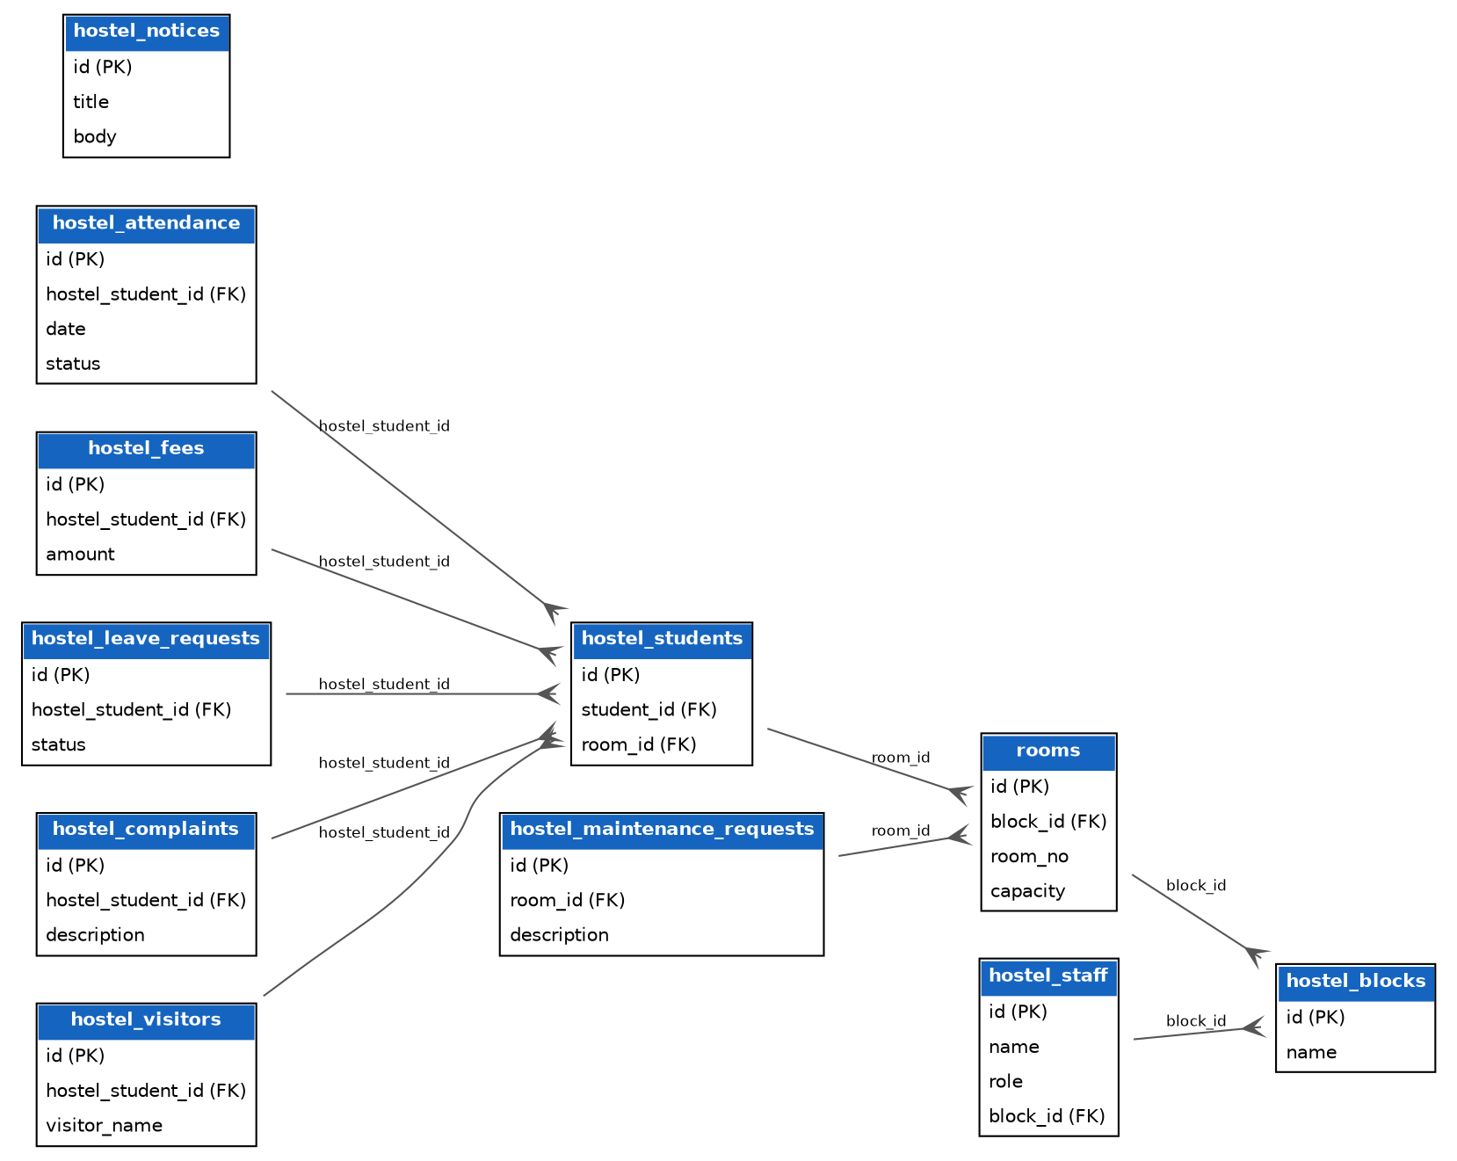

6.5 Transport — ER Diagram
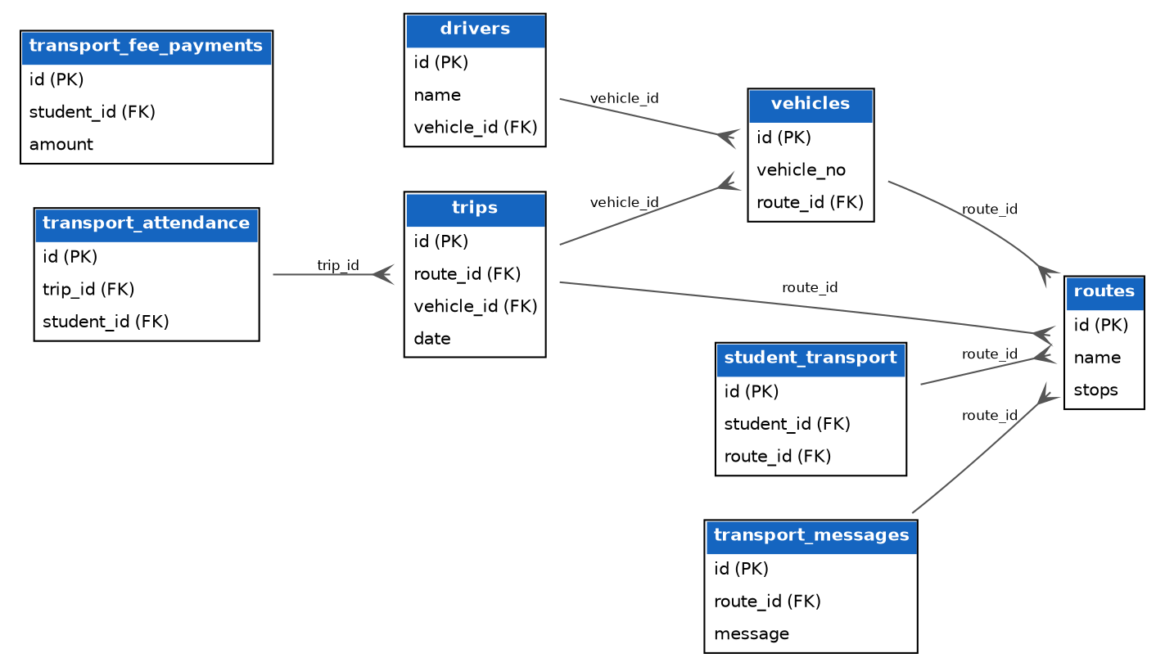

6.6 HR & Payroll — ER Diagram
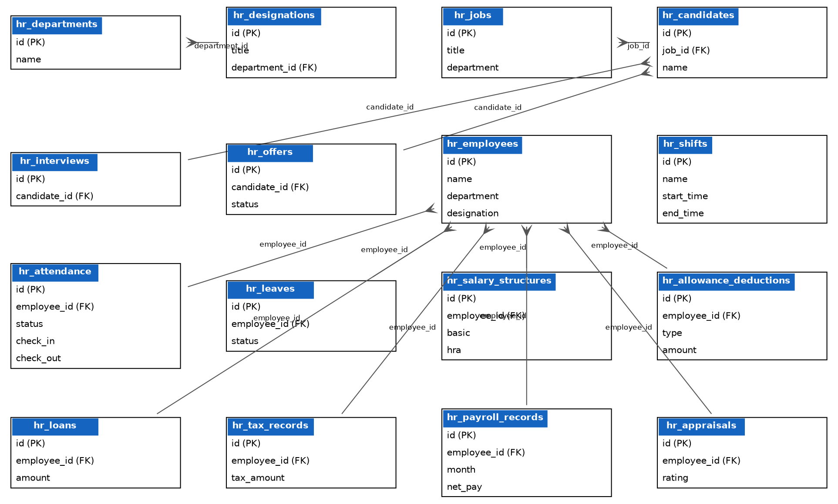

6.7 Teacher Portal + Parents & Communication — ER Diagram
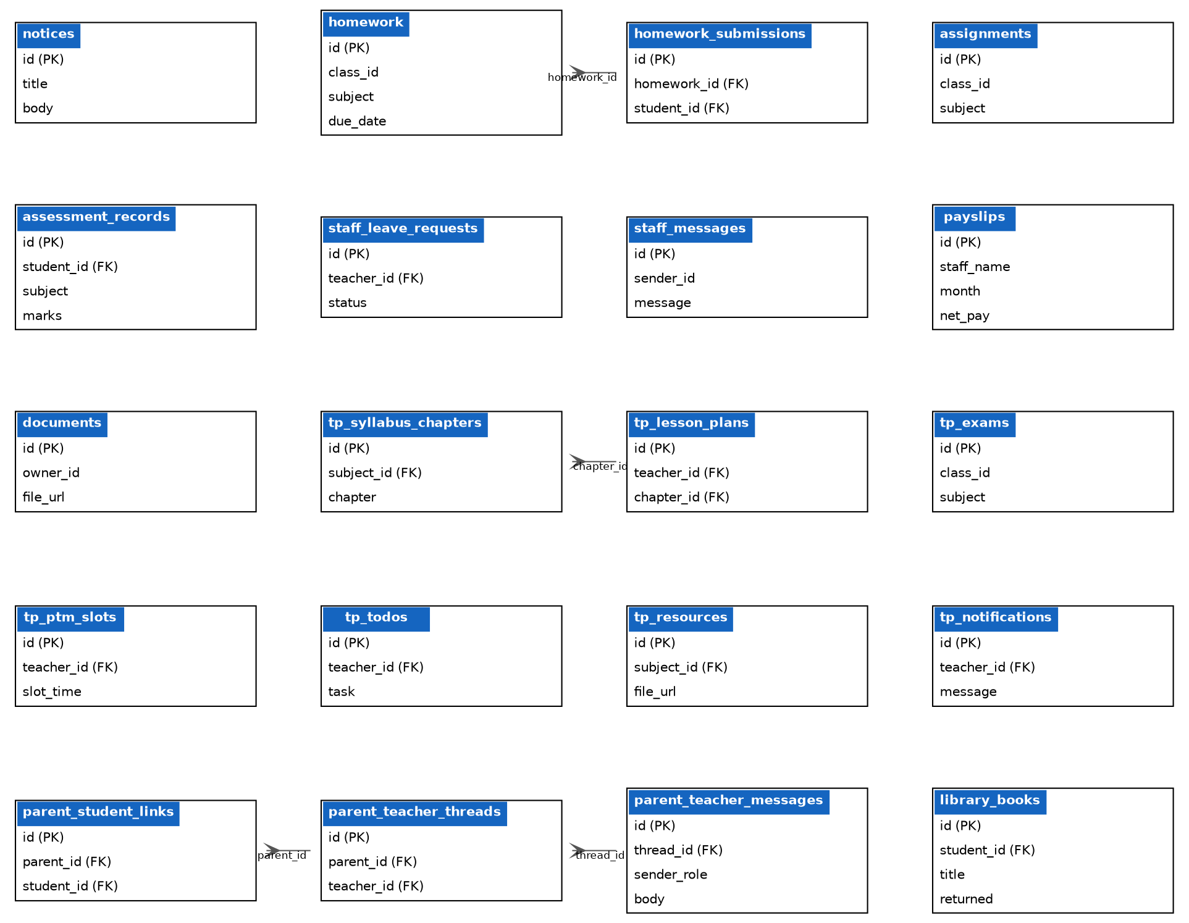

7. Conclusion and Notes
This document was prepared by scanning the entire School CRM/ERP codebase (378+ Dart files across 12 modules). It covers all 104 tables, their columns (as far as could be traced from the code), and the process flow of every module.

Important Notes
- Almost every table also has an `id` (primary key), `institution_id` (multi-tenant scoping) and `created_at` column, even where these are not explicitly listed in every column list below.
- Some tables' columns come only from a bare `.select()` call (i.e. `select('*')`) — for those tables, the column list has been derived from wherever the app inserts/updates that table, so it may not be 100% exhaustive. For the exact column list, cross-check against the Supabase project's table editor / SQL schema.
- Foreign key relationships (e.g. student_id, teacher_id, exam_id) have been identified from column-naming convention (the `_id` suffix) — the actual database may or may not have a formal FK constraint on these; some may be soft references only.
- The Transport module's dropdown lists (route/driver/vehicle names) are still on static mock data — this is a known gap already flagged in your project's own BACKEND_STATUS.md.
- This entire document was built code-first — meaning it is not theory or assumption, but has been extracted directly from the Supabase queries present in your actual `.dart` files.

